Portfolio Project on

Global AI Job Market Trends & Salary Insights 2025
using

SQL & Power BI
BY
Jeevitha G..

1. Project Overview
The Global AI Job Market Trends & Salary Insights 2025 project is designed to analyse the rapidly evolving AI job landscape using SQL-based data engineering and Power BI–driven visualization techniques.
The goal of this project is to uncover:
- Salary trends across job titles, industries, countries, and company sizes
- Skill demand patterns and highest-paying technologies
- Experience-level expectations and hiring trends
- Work mode adoption (onsite / hybrid / remote)
- Company- and industry-level performance insights
This project provides hiring managers, job seekers, and business leaders with data-backed intelligence around salaries, demand trends, growth areas, and global opportunities.
The solution includes:
✔ SQL-driven Exploratory Data Analysis
✔ Power BI interactive dashboards
✔ Skill-demand modelling & ranking systems
✔ Industry-level salary benchmarking
✔ Experience-level insights
✔ Advanced DAX measures
✔ A full end-to-end data workflow: ingestion → cleaning → transformation → modelling → visualization

2. Project Objectives
The project is structured around seven clear objectives:

1) Data Exploration & Understanding
- Understand dataset structure and schema
- Explore salary data, skills lists, and job descriptions
- Identify relationships between salary, skills, experience, and industry

2) Salary Insights Across Multiple Dimensions
- Salary by job title
- Salary by industry
- Salary by company location
- Salary progression by experience

3) Experience-Level & Employment-Type Analysis
- Which levels (L/M/S/SE/MI) are in high demand?
- Which employment types dominate hiring (CT/FT/PT/FL)?

4) Work Mode Analysis
- Remote, Hybrid, and Onsite job preferences
- Relationship between remote ratio and salary

5) Skill Demand & Skill Revenue Analysis
- Most demanded skills in the AI job market
- Skills associated with highest salaries
- Industry-specific top skills

6) Company & Industry Insights
- Top hiring companies
- Highest-paying industries
- Company-size distribution & salary comparison

7) Actionable Insights for Stakeholders
- For job seekers: skills to prioritize & industries to target
- For companies: salary benchmarking & skill-gap insights
- For industry analysts: AI hiring and salary trends across countries

3. Data Acquisition
The dataset includes the following fields:
job_id, job_title, salary_usd, salary_currency,
experience_level, employment_type, company_location,
company_size, employee_residence, remote_ratio,
required_skills, education_required, years_experience,
industry, posting_date, application_deadline,
job_description_length, benefits_score, company_name
The data was sourced as a structured CSV representation of real-world AI job postings.
It was prepared for ingestion by ensuring consistent formatting, valid dates, and standardized delimiters.

4. Data Loading into SQL
Steps followed:
- Created SQL database: aijobs_db
- Created table aijobs with appropriate data types
- Loaded CSV using Workbench Import Wizard
- Validated row count & schema alignment
Example schema choices:
- Salary: DECIMAL(10,2)
- Years of experience: INT
- Posting & deadline dates: DATE
- Required skills: TEXT
- Benefits score: DECIMAL(3,1)

5. Data Cleaning
Key cleaning activities included:

✔ Missing Value Identification
Using SQL queries to check missing values in salary, skills, and posting date fields.

✔ Standardizing Formats
- Normalized date formats to YYYY-MM-DD
- Trimmed whitespace from skills and job titles
- Ensured salary_usd is numeric (already converted to USD)

✔ Removing Noise & Inconsistencies
- Unified industry names
- Fixed country names where necessary
- Removed invalid characters from skill lists

✔ Skill Splitting Preparation
A numbers table (1–10) was created to split the comma-separated required_skills field into atomic values.

6. Data Transformation
Transformations applied:

✔ Skill Extraction
Using SUBSTRING_INDEX logic to extract skills from comma-separated fields.

✔ Feature Engineering
- Skill count per job
- Days open for applications
- Salary category ranges

✔ Derived Dimensions
- WorkMode (Remote/Hybrid/Onsite) based on remote_ratio
- EducationGroup based on degree levels

✔ Aggregations
- Avg salary per industry
- Salary distribution by company size
- Skills demand aggregated by skill frequency

7. MECE Breakdown
The analysis was structured using the MECE framework:

1. Salary Analysis
- Job title
- Experience
- Industry
- Geography
- Company size

2. Skill Analysis
- Demand frequency
- Highest-paying skills
- Industry-specific top skills
- Avg skill count per experience level

3. Work Mode & Employment Insights
- Remote vs hybrid vs onsite
- Employment type patterns
- Salary differences between work modes

4. Company & Industry Analysis
- Top hiring companies
- Industry salary benchmarks
- Benefits score patterns
This avoided overlap and ensured complete coverage of every analytical dimension.

Connecting with Analytical Tools

SQL and Power BI serve as the primary tools for handling, analysing, and visualizing the data.
- SQL Integration:
  - Extracts, manipulates, and queries structured relational databases efficiently.
  - Enables real-time exploration and filtering of university-related data.
- Power BI Integration:
  - Facilitates seamless import and visualization of CSV data.
  - Ensures compatibility, consistency, and transformation capabilities within Power BI’s environment.
  - Enables dynamic, interactive dashboards for a user-friendly analysis experience.
The integration of these tools enhances data accessibility and interpretability across multiple stages of the project.

8. Exploratory Data Analysis using SQL

CSV Import Process
To begin the analysis, the AI Jobs dataset was imported into SQL for structured querying and exploratory data analysis.
Steps followed:
- Open your SQL management tool (e.g., MySQL Workbench, Azure Data Studio, DBeaver).
- Navigate to Server → Data Import Wizard (in MySQL Workbench) or equivalent in your tool.
- Select AI_Jobs.csv (your dataset file) as the source.
- Choose Import to Existing Table → aijobs or allow the tool to create a new table if needed.
- Map each column correctly to ensure data type accuracy:
Your SQL queries covered:
- Data quality checks
- Salary benchmarking
- Industry-wise job counts
- Experience-level percentages
- Remote-work distributions
- Skill extraction & ranking
- Top-paying industries & skills
- Application-window calculations

Data Quality & Preparation Queries
- Check Row Count
SELECT COUNT(*) AS Total_Jobs FROM aijobs;

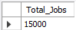
- Check Missing Values
SELECT
SUM(CASE WHEN salary_usd IS NULL THEN 1 END) AS Missing_Salary,
SUM( CASE WHEN required_skills IS NULL THEN 1 END) AS Missing_skills,
SUM(CASE WHEN posting_date IS NULL THEN 1 END) AS Missing_Posting_Date

FROM aijobs;
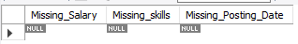

Salary Analysis Queries

Average Salary By Job Title
SELECT job_title, ROUND(AVG(salary_usd),1) AverageSalary
FROM aijobs
GROUP BY job_title
Order BY AVG(salary_usd) DESC;

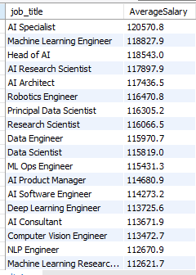

Average Salary By Company Location
SELECT company_location, ROUND(AVG(salary_usd),1) AverageSalary
FROM aijobs
GROUP BY company_location
Order BY AVG(salary_usd) DESC;

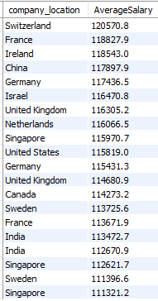

Average Salary By Industry

SELECT industry, ROUND(AVG(salary_usd),1) AverageSalary
FROM aijobs
GROUP BY industry
Order BY AVG(salary_usd) DESC;
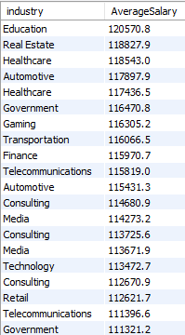

Salary Growth with Experience
SELECT years_experience, ROUND(AVG(salary_usd),2) Average_Salary
FROM aijobs
GROUP BY years_experience;
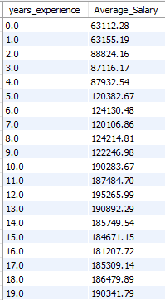

Job Distribution & Hiring Trend Queries

Jobs Posted per Industry
SELECT industry, COUNT(*) AS TotalJobs
FROM aijobs
GROUP BY industry
ORDER BY COUNT(*) DESC;
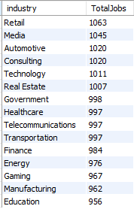

Monthly Job Posting Trend
SELECT MONTH(posting_date) AS Month, YEAR(posting_date) AS YEAR, Count(*) AS TotalJobs
FROM aijobs
GROUP BY MONTH(posting_date),YEAR(posting_date)
ORDER BY MONTH(posting_date),YEAR(posting_date) ;

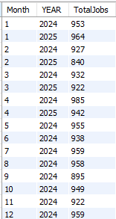
- Experience Level Distribution
SELECT years_experience , Count(*) AS TotalJobs,
concat(ROUND(COUNT(*)*100/(SELECT COUNT(*) FROM aijobs),2),'%') AS PercentageJobs
FROM aijobs
GROUP BY years_experience
ORDER BY years_experience ;
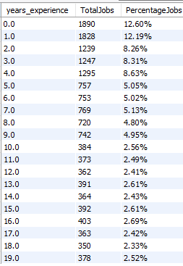
- Best Job Roles for Freshers
SELECT job_title, ROUND(AVG(salary_usd),2) Average_Salary,years_experience
FROM aijobs
WHERE years_experience<=2
GROUP BY job_title
ORDER BY Average_Salary DESC
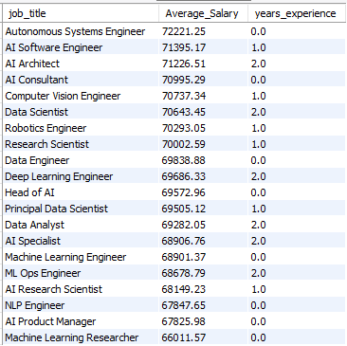

- Employment Type Distribution
SELECT employment_type, COUNT(*) as Total_Jobs
FROM aijobs
GROUP BY employment_type
ORDER BY COUNT(*);
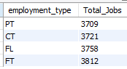

REMOTE WORK ANALYSIS
- Count by Remote Ratio
SELECT remote_ratio, COUNT(*) as Total_Jobs
FROM aijobs
GROUP BY remote_ratio
ORDER BY COUNT(*);
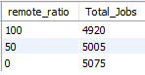

- Remote vs Onsite %
SELECT
CASE WHEN remote_ratio=100 THEN "Remote"
WHEN remote_ratio=50 THEN "Hybrid"
WHEN remote_ratio=0 THEN "Onsite"
END AS WorkMode, COUNT(*) Total_Jobs,
CONCAT(ROUND(COUNT(*)*100/(SELECT COUNT(*) FROM aijobs),2),'%') AS Percentage
FROM aijobs GROUP BY WorkMode;
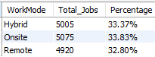

BENEFITS & COMPANY ANALYSIS

Average Benefits Score by Company
SELECT company_name, ROUND(AVG(benefits_score),2) as Avg_BenifitScore
FROM aijobs
GROUP BY company_name

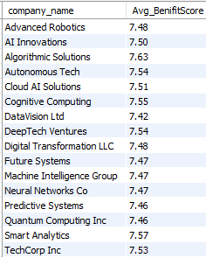

- Job Count by Company Size
SELECT company_size, COUNT(*) Total_Jobs
FROM aijobs
GROUP BY company_size

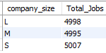

APPLICATION TIMELINE ANALYSIS
- Days Open for Applications
SELECT job_id, posting_date, DATEDIFF(application_deadline,posting_date) AS DaysOpen
FROM aijobs
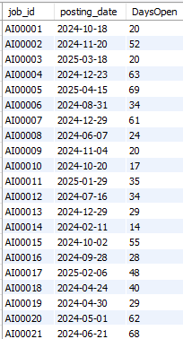

SKILL ANALYSIS
NUMBERS TABLE CREATION
CREATE TABLE numbers
( n INT PRIMARY KEY );
INSERT INTO numbers
VALUES(1),(2),(3),(4),(5),(6),(7),(8),(9),(10);

- Skill Frequency

SELECT skills, COUNT(*) skills_Frequency FROM
(
SELECT TRIM(SUBSTRING_INDEX(SUBSTRING_INDEX(required_skills,',',n),',',-1)) AS skills
FROM aijobs

JOIN numbers n
ON CHAR_LENGTH(required_skills)-CHAR_LENGTH(REPLACE(required_skills,',','')) >=n.n -1
) tt
GROUP BY skills
ORDER BY skills_Frequency DESC;

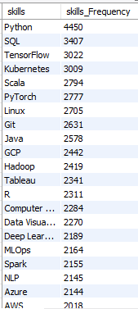

- Highest Paying Skills
SELECT skills,ROUND(AVG(salary_usd),2) Average_salary
FROM
(
SELECT salary_usd,TRIM(SUBSTRING_INDEX(SUBSTRING_INDEX(required_skills,",",n),",",-1)) skills
FROM aijobs
JOIN numbers n
ON CHAR_LENGTH(required_skills)-CHAR_LENGTH(REPLACE(required_skills,",",""))>=n.n-1
) tt
GROUP BY skills
ORDER BY Average_salary DESC

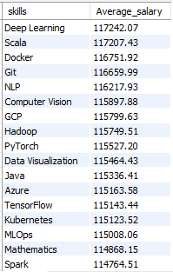

- Top Skills demand by Industry
WITH skillcount AS
(SELECT industry,skills,frequency
FROM
(
SELECT industry, COUNT(*) AS frequency,TRIM(SUBSTRING_INDEX(SUBSTRING_INDEX(required_skills,",",n),",",-1)) skills
FROM aijobs
JOIN numbers n
ON CHAR_LENGTH(required_skills)-CHAR_LENGTH(REPLACE(required_skills,",",""))>=n.n-1
GROUP BY skills,industry
) tt

ORDER BY industry,frequency DESC),

ranked AS
(SELECT industry,skills,frequency,
ROW_NUMBER()OVER(PARTITION BY industry ORDER BY frequency DESC) AS rn
FROM skillcount
GROUP BY industry,skills
)
SELECT industry,skills,frequency FROM ranked
WHERE rn<=5

ORDER BY industry,frequency DESC

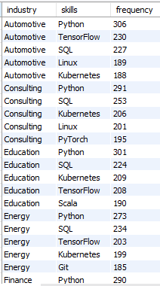

- Skill Count Per Job
SELECT job_id, required_skills,
CHAR_LENGTH(required_skills)-CHAR_LENGTH(REPLACE(required_skills,',',''))+1 skillsCount
FROM aijobs
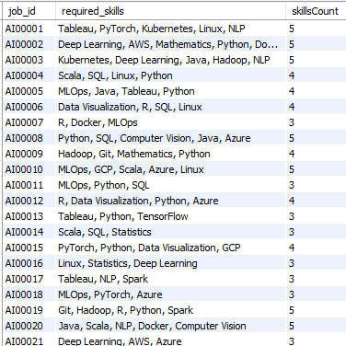

- Experience Levels Require the Most Skills
SELECT years_experience, ROUND(AVG(skillCount),1) AvgSkillsRequired
FROM (
SELECT years_experience, job_id, required_skills,
CHAR_LENGTH(required_skills)-CHAR_LENGTH(REPLACE(required_skills,',',''))+1 skillCount
FROM aijobs)tt
GROUP BY years_experience
ORDER BY years_experience

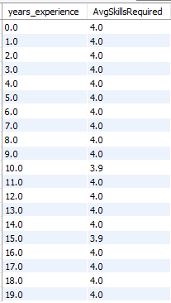

- Skills Required by Top-Paying Industries
WITH highpayIndustries AS
(SELECT industry, ROUND(avg(salary_usd),2) Avg_Salary FROM aijobs
GROUP BY industry
Order BY Avg_Salary DESC
LIMIT 3)

SELECT hp.industry,hp.Avg_Salary,t.skills,COUNT(*) demand
FROM(

SELECT industry, TRIM(SUBSTRING_INDEX(SUBSTRING_INDEX(required_skills,",",n),',',-1)) skills
FROM aijobs
JOIN numbers n
ON CHAR_LENGTH(required_skills)-CHAR_LENGTH(REPLACE(required_skills,',',''))>=n.n-1) t

JOIN highpayIndustries hp
ON t.industry=hp.industry

GROUP BY t.industry, t.skills
ORDER BY t.industry, demand DESC;

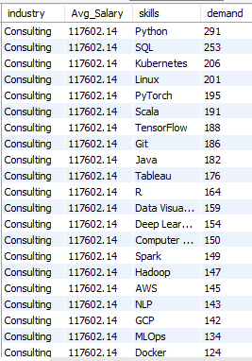

9. Power BI Analysis & Dashboard Development

Dashboard 1: Global AI Salary Trends
Includes:
- Top hiring country
- Salary by job title
- Salary by industry
- Salary by company size
- Global map of salary distribution
- Salary trend over time
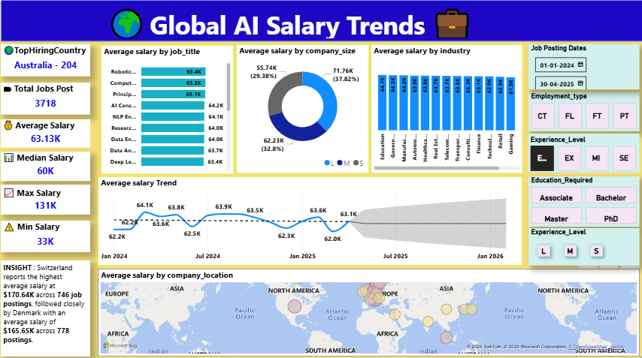

Dashboard 2: Skill Demand & Remote Work Dashboard
Includes:
- Total unique skills
- Top demanded & top paying skills
- Work mode distribution
- Education requirement by work mode
- Country vs remote work
- Remote ratio vs avg salary
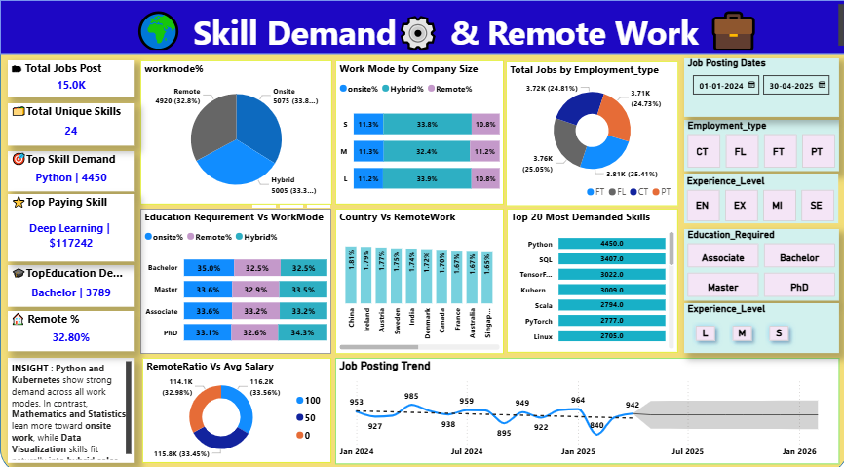

Dashboard 3: Industry & Company Insights
Includes:
- Top hiring industries & companies
- Avg salary by industry
- Company-size salary distribution
- Benefits score by company
- Industry hiring timeline
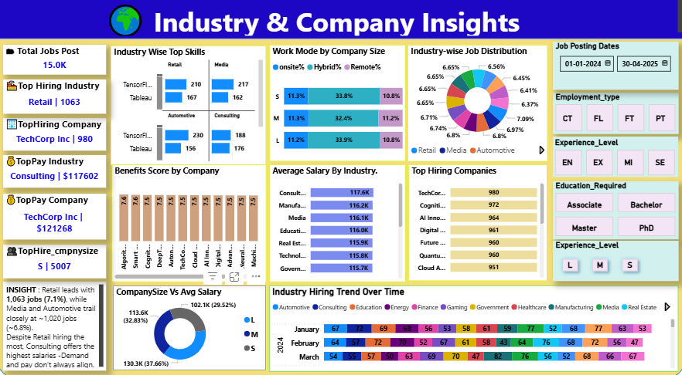

10. DAX Measures Used
Includes:
- Total Jobs
- Average Salary
- Salary Trend
- Work Mode %
- Skill Count
- Filters & slicer measures

Basic KPI Measures

Total Jobs
Total Jobs = COUNTROWS(aijobs)

Average Salary
Average Salary = AVERAGE(aijobs[salary_usd])

Highest Salary
Highest Salary = MAX(aijobs[salary_usd])

Lowest Salary

Lowest Salary = MIN(aijobs[salary_usd])

Hybrid%

VAR coun=countrows(FILTER(aijob,aijob[remote_ratio]=50))

VAR totcoun=COUNTROWS(aijob)

RETURN DIVIDE(coun,totcoun)

onsite%

DIVIDE(

CALCULATE(COUNTROWS(aijob),aijob[remote_ratio]=0),

CALCULATE(COUNTROWS(aijob),ALL(aijob)))

Remote%

DIVIDE(

CALCULATE(COUNTROWS(aijob),aijob[remote_ratio]=100),

CALCULATE(COUNTROWS(aijob),ALL(aijob)))

Average Salary

Average Salary = AVERAGE(aijobs[salary_usd])

Total Jobs

Total Jobs = COUNTROWS(aijobs)

Total Unique Skills

Total Unique Skills = DISTINCTCOUNT(Skills[skill])

Top Skill in Demand

VAR t =

ADDCOLUMNS(

VALUES(Skills[skill]),

"SkillCount", COUNTROWS(Skills)

)

VAR top1 =

TOPN(1, t, [SkillCount], DESC)

RETURN

CONCATENATEX(top1, Skills[skill], ", ")

Top Paying Skill

VAR t =

ADDCOLUMNS(

SUMMARIZE(Skills, Skills[skill]),

"AvgSalary", CALCULATE(AVERAGE(aijobs[salary_usd]))

)

VAR top1 =

TOPN(1, t, [AvgSalary], DESC)

RETURN

CONCATENATEX(top1, Skills[skill], ", ")

Top Paying Company

VAR payee=

ADDCOLUMNS(VALUES(aijob[company_name]),"pay",CALCULATE(AVERAGE(aijob[salary_usd])))

VAR TOPAY=TOPN(1,payee,[pay],DESC)

RETURN CONCATENATEX(TOPAY,aijob[company_name]& " | $" & ROUND([pay],0))

Top Hiring Industry

VAR indcount=

ADDCOLUMNS(

VALUES(aijob[industry]),"jobs",CALCULATE(COUNTROWS(aijob)))

VAR toph=

TOPN(1,indcount,[jobs],DESC)

RETURN CONCATENATEX(toph,aijob[industry] &" | " & [jobs])

Top Hiring Country

VAR CT= SUMMARIZE(aijob,aijob[company_location],"counti",COUNTROWS(aijob)) VAR topi =

TOPN(1,CT,[counti],DESC)

RETURN CONCATENATEX(topi,aijob[company_location] & " "&[counti])

Top Hiring company Size

VAR csiz=

ADDCOLUMNS(VALUES(aijob[company_size]),"siz",CALCULATE(countrows(aijob)))

VAR topz=TOPN(1,csiz,[siz],DESC)

RETURN CONCATENATEX(topz,aijob[company_size]&" | "&[siz])

Top Education Required

VAR TEd=

SUMMARIZE(aijob,aijob[education_required],"Edcount",countrows(aijob)) VAR toped=TOPN(1,TEd,[Edcount],DESC)

RETURN CONCATENATEX(toped,aijob[education_required]& " | " &[Edcount])

11. Project Insights
Key findings include:

✔ Highest-paying industries
- Consulting
- Manufacturing
- Tech Services

✔ Top-demand skills
- Python
- SQL
- Kubernetes
- Machine Learning
- Deep Learning

✔ Highest-paying skills
- Deep Learning
- NLP
- AWS
- Java
- Hadoop

✔ Remote roles
~33% of jobs are remote. Hybrid dominates in many industries.

✔ Salary distribution
- Top salary ≈ $131K
- Median salary ≈ $60K
- Lowest salary ≈ $33K

✔ Skill intensity
Higher experience levels require more skills (avg 7–12).

12. Conclusion
The AI Jobs 2025 Project delivers a comprehensive, SQL-powered and Power BI–driven analysis of global AI hiring trends. The combination of skill extraction logic, salary analytics, and advanced dashboards enables stakeholders to understand:
- What skills drive income
- Which industries pay the most
- How hiring patterns vary by geography
- How remote work influences salary
- Which companies and industries dominate AI recruitment
This project demonstrates advanced capabilities in:
✔ SQL (complex string parsing, window functions, aggregations)
✔ Data engineering (cleaning, transformation, feature extraction)
✔ Power BI (modelling, DAX, interactive dashboards)
And serves as a strong portfolio asset for your transition into data analytics.

13. Significance of the Project
This project is significant because it:
- Helps job-seekers understand which skills to learn
- Assists companies in benchmarking salaries
- Provides insights for AI workforce planning
- Reveals global patterns in AI talent distribution
- Demonstrates a real-world end-to-end analytics workflow

